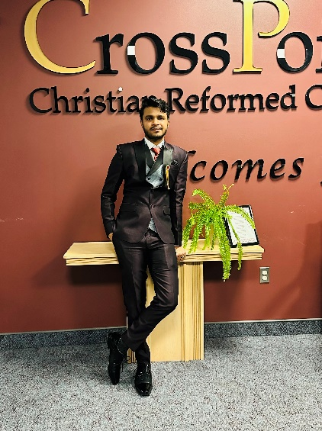

In a world flooded with digital profiles, carving a distinct personal brand has become essential. Welcome to my journey – I am Neron Parmar, I'll share how I've embarked on the adventure of crafting my personal brand.

My exploration began with self-discovery. Understanding my strengths, passions, and aspirations laid the cornerstone of my personal brand. This self-awareness not only fuels my drive but also gives authenticity to my narrative, allowing me to connect with my audience on a deeper level. At the heart of my branding strategy lies in my people. By identifying and empathizing with their needs, I tailor my brand to resonate with them. Whether they're tech enthusiasts, creative minds, or aspiring entrepreneurs, my aim is to offer something valuable and relatable.

Consistency has been key in maintaining a recognizable brand across various platforms. From visuals to the tone of my communication, I strive for a cohesive identity that fosters familiarity and trust. I share my expertise and insights by thought-provoking articles to engaging videos, I position myself as a thought leader in my field. This consistency not only builds credibility but also draws a community that resonates with my ideas.

Networking is another cornerstone of my branding journey. Attending events, collaborating with peers, and participating in online forums, I build connections that transcend the digital realm. Above all, authenticity drives my personal brand. Every achievement, every story, and every interaction is a reflection of who I am. This authenticity not only attracts people but also forms the basis of genuine relationships built on trust.

In the realm of personal branding, my journey stands as a testament to the power of authenticity, understanding your audience, and maintaining consistency. As I continue to evolve, my personal brand evolves with me, a story told through every connection and interaction. So, this was me Neron Parmar hope you have enjoyed knowing about me.